Name – Yash Sasane

Roll No. – 681

PRN – 202201050052

# Practical Assignment 1a

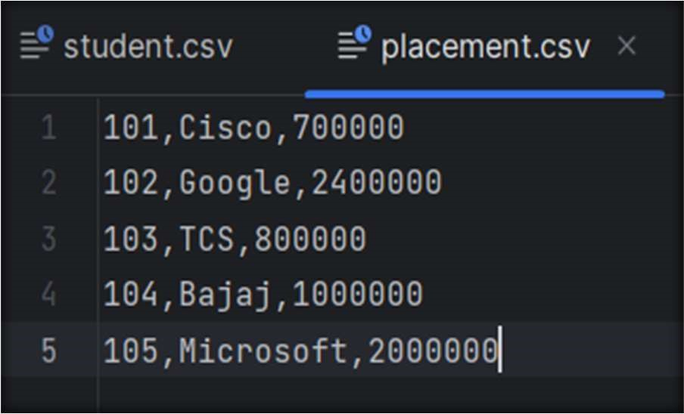

|  |
| --- |
| f1=open("student.csv","r") f2=open("placement.csv","r") f3=open("student_detail.csv","w") contents1=f1.read() contents2=f2.read() print(contents1) print(contents2) nm=[] package=[] lines1=contents1.split("\n") lines2=contents2.split("\n") lines1.pop() lines2.pop()  for l1 in lines1: words1 = l1.split(",") for l2 in lines2:  words2 = l2.split(",") if (words1[0] == words2[0]):  l1 = l1 + "," + words2[1] + "," + words2[2] + "\n" f3.write(l1)  nm.append(words1[1]) package.append(int(words2[2]))  f1.close() f2.close() f3.close() |

.csv file

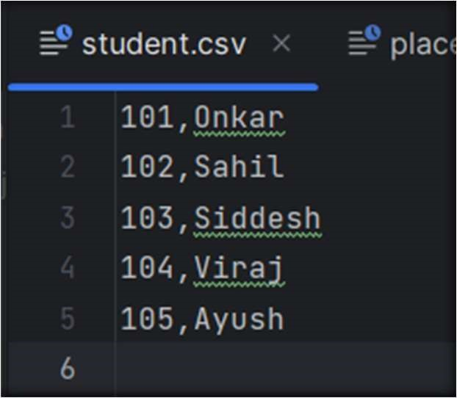

OUTPUT :

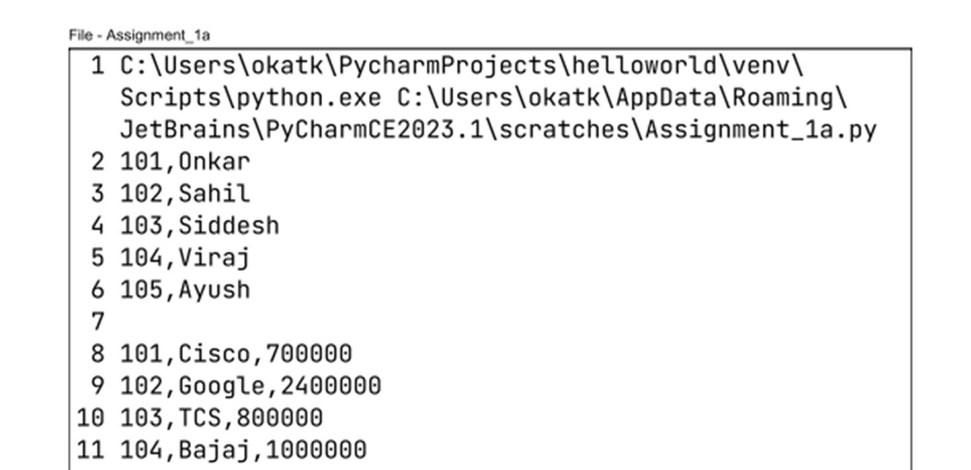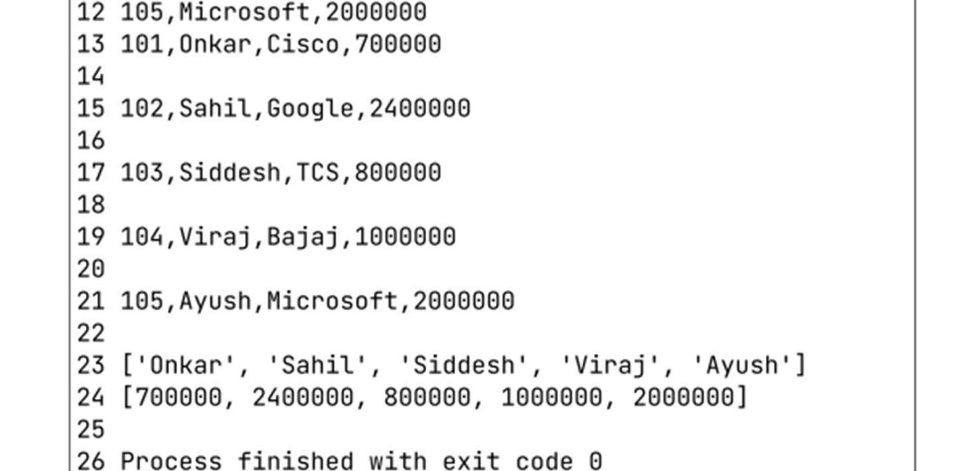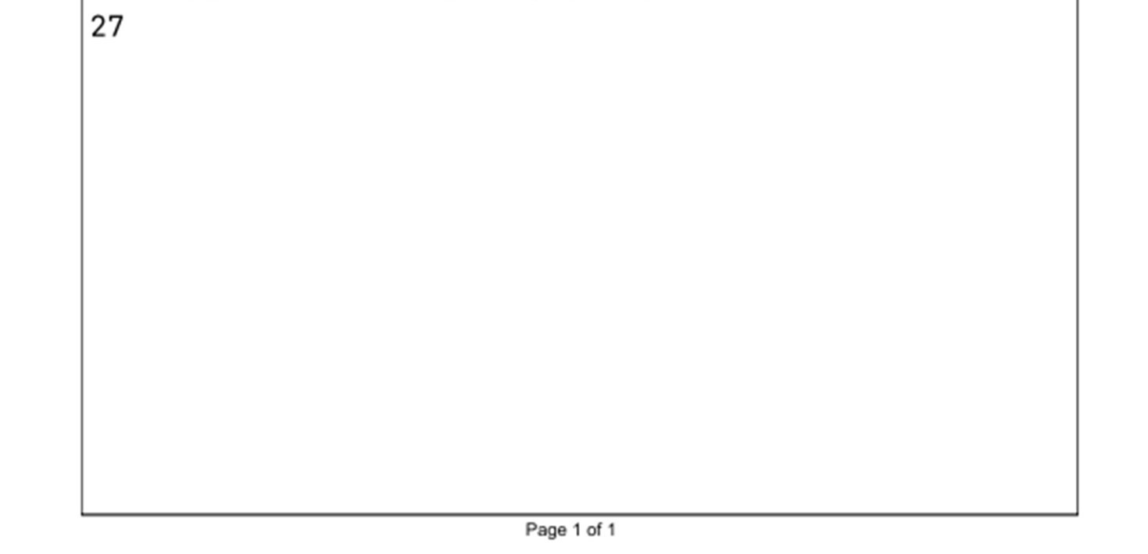

# Assignment 1b

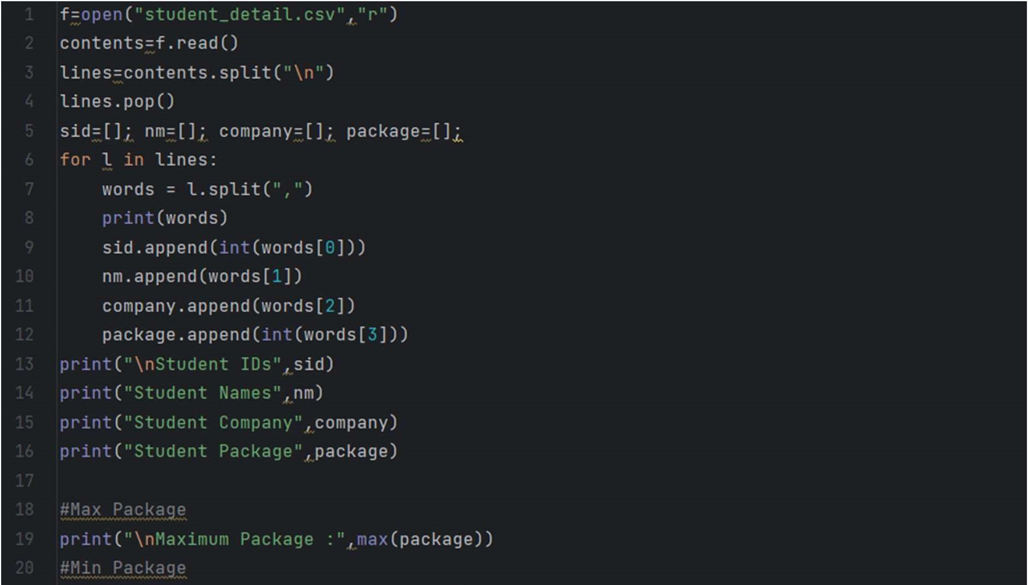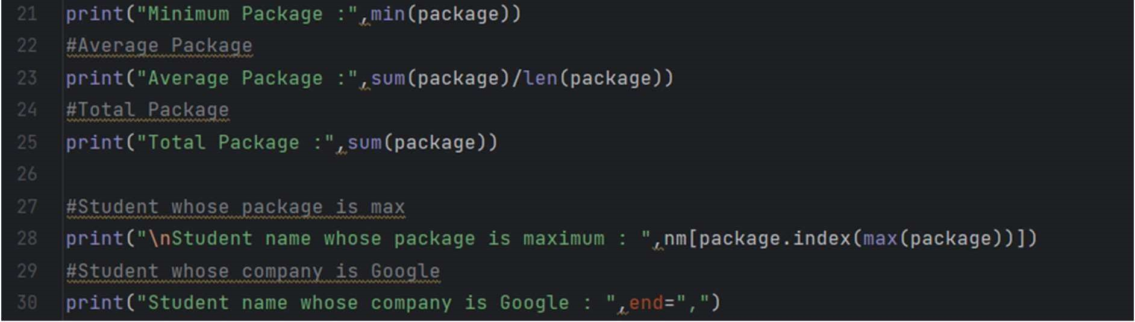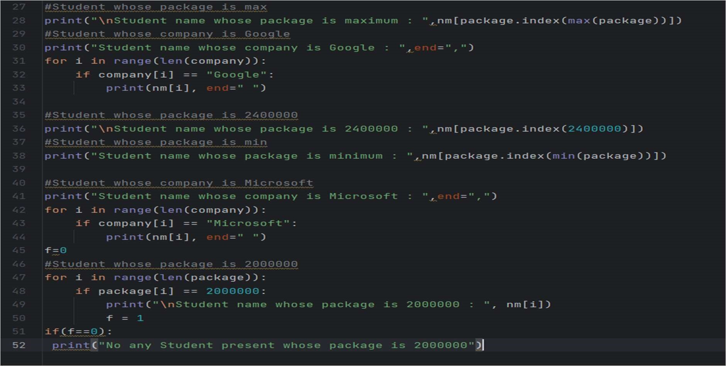

.csv file

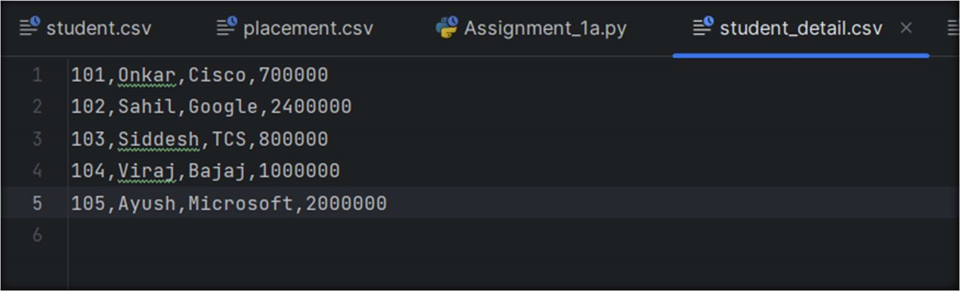

OUTPUT :

